**Case Study-The NY Fashion Company**

1. **Abstract**

The NY Fashion Company focuses on designing and producing fashion clothing for women. After they completed the designing, it is high time to formulate production plan for the fall line. We employ linear programming to maximize the total profit, which is the difference between total revenue and total cost. The linear programming also generates the optimal configuration of units for each pattern, which can be used in two costing methods, traditional volume-based costing and activity-based costing. Each costing method has its advantages and disadvantages, but the goal of both costing methods is to compute unit profit, which provides great convenience for the calculation of net total profit.

1. **Introduction**

As the owner of the NY Fashion Company, Diana Ricks is responsible to lead the fashion for women’s clothing. Casual clothing and professional clothing are the two categories in fall line. Since fall clothing must be launched in market, now the most urgent issue that Diana is facing is to figure out the optimal number of each item, which would result in the highest profits. The calculation of the quantity of items and maximum profit must be constrained by resource limitation, capacity of production, and sales department’s demand forecasts.

Before the production starting, Diana has paid for three prestigious fashion shows in the world, overhead costs, and designer salary, and these costs can be served as fixed cost. Labor cost, machine cost, and material cost can be treated as variable cost that is close associated with item quantity. The price for each item has been set based on the brand and item itself.

1. **Methodology**

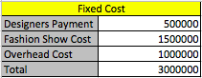Prior to proceed to calculation, we should gather and organize the information. All the fixed cost information is available in this case, shown in ***Table 1***.

***Table 1***

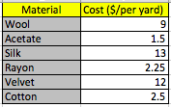Unit cost of each material is indicated in ***Table 2***.

***Table 2***

Labor price is $20 per hour, and the price of machine working is $10 per hour.

For each item, price, required materials and material size, labor hours, machine working hours are listed in ***Table 3***.

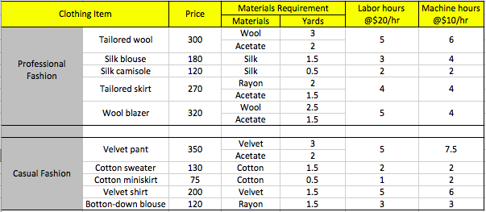

***Table 3***

Given the above given information, we can calculate variable cost, including machine cost, labor cost, and material cost. Then margin for each item can be figured out through the formula, “margin = price –material cost-labor cost-machine cost”. Let’s take the items tailored wool and silk blouse for examples.

For one tailored wool, it needs 3 yards of wool, 2 yards of acetate, 5 hours of labor, and 6 hours of machine working, so the calculation for the margin of one tailored wool is:

Margin = price –material cost-labor cost-machine cost=$300-(3 yards wool*$9per yard+2 yards acetate*$1.5 per yard)-5 hours of labor*$20per hour- 6 hours of machine*$10 per hour = $110

For one silk blouse, simply, the calculation of the margin is:

Margin = $180-1.5*$13-3*$20-4*$10 = $60.5

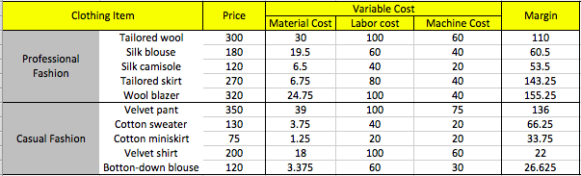Similarly, we calculate variable cost and margin for other items, and combine them into ***Table 4.***

***Table 4.***

* 1. **Linear Programing Model**

In order to simplify the formula, let’s give each item a ID, i. For example, 1 stands for tailored wool, and 2 is the other name of silk blouse. The ID can be found in ***Table 5.*** Let’s define “Mari”, which is also available in ***Table 5,*** as the margin for item i,

**Decision variable:**

Xi: number of item i to product.

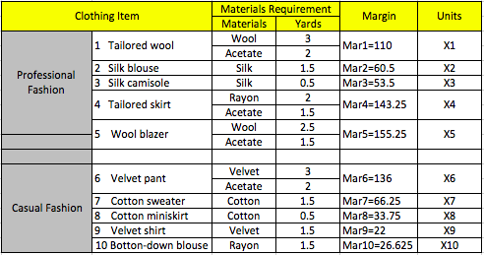

***Table 5***

**Objective function:**

Maximize profit = $\sum_{i=1}^{10}{(Mari*Xi)}$-Total fixed cost

$=\sum_{i=1}^{10}{(Mari*Xi)}$-3000,000

**Constraints:**

1. Resources limitation

3*X1+2.5*X5 $≤$ 45,000 Wool

2*X1+1.5*X4+1.5*X5+2*X6 $≤$ 28,000 Acetate

1.5*X2+0.5*X3 $≤$ 18,000 Silk

2*X4+1.5*X10 $≤$ 30,000 Rayon

3*X6+1.5*X9 $≤$ 20,000 Velvet

1.5*X7+0.5*X8 $≤$ 30,000 Cotton

1. Demand forecast limitation

X6 $≤$ 5,500 Velvet pant

X9 $≤$ 6,000 Velvet shirt

X2 $≤$ 12,000 Silk blouse

X3 $≤$ 15,000 Silk camisole

1. Other limitation

Whenever product one silk blouse, the leftover material can be make a silk camisole.

X2 $≤$ X3

Whenever product one cotton sweater, the leftover scraps can be make a silk miniskirt.

X7 $≤$ X8

**Solutions:**

Then, run solver in Excel, and choose “Simplex LP” as the solving method. We get maximum total benefit $3,781,833.33. Under the optimal condition, the quantity distribution of items is listed in ***Table 6.*** Tailored wool, velvet pant, and cotton sweater won’t be produced in fall line. The most item will be made is cotton miniskirt, and 60,000 units of cotton miniskirt are going to be manufactured. Wool blazer, which has the highest margin, will be the product with second largest product volume, 18,000 units.

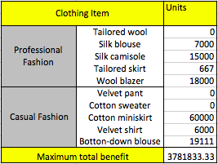***Table 6***

* 1. **Sensitivity Analysis**

Sensitivity Report could be generated when we run Solver in Excel. The sensitivity report about constraints is shown in ***Table 7***. In this case, acetate can be increased by 10,000 yards, so we only need to locate the row of “Acetate Total Yards”. According to sensitivity analysis of the right-hand side decision, within feasible range, the formula of increase in the total profit is:

The increase in the maximum total profit = DAcetate* Shadow price

DAcetate means the increase in available acetate, which is a constraint in Linear Programming. Feasible range depends on corresponding allowable increase and allowable decrease. From ***Table 7***, we can see the feasible range for DAcetate is from -1000 to 21500, so 10,000 yards increase of acetate falls in the range. Therefore, we can use the above formula.

* The increase in the maximum total profit = 10,000* 71.8333.3=718,333.3
* The new maximum total profit = 3,781,833.3+718,333.3=4,500,167
* Next, we also validate the rule via changing the constraint and running solver.

2*X1+1.5*X4+1.5*X5+2*X6 $≤$ 28,000

changes into

2*X1+1.5*X4+1.5*X5+2*X6 $≤$ 28,000+10,000

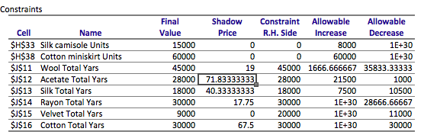 The results of running solver again, the total profit is updated as 4,500,167 which is exactly same as our calculation above. The updated optimal solution is listed in ***Table 8***.

***Table 7***

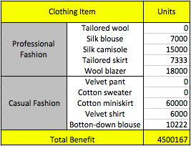***Table 8***

* 1. **Traditional Volume-Based Costing Method**

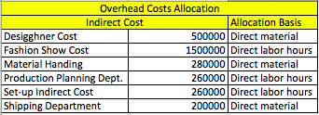Traditional volume-based costing method refers to that overhead is proportionally distributed to other jobs or activities on a volume-oriented basis (Pondent, 2017). For example, in this case, the higher the total material cost is for one item, the more overhead costs are allocated to this item. In the same way, the higher the total labor cost is for one item, the more overhead costs are allocated to this item. The indirect cost and allocation basis are listed in ***Table 9.***

***Table 9***

Given the information in ***Table 9,***

Material cost allocated by overhead costs=500,000+280,000+200,000=980,000

Labor cost allocated by overhead costs=1,500,000+260,000+260,000=2,020,000

We already know unit material cost, unit labor cost, unit machine cost, and numbers for each item, which are listed in ***Table 10***, so allocated unit material cost and allocated unit labor cost for item i can be calculated.

Total material cost for all items= $\sum_{i=1}^{10}{(unit material cost for item i*units for item i)}$

=931,500

Total labor cost for all items= $\sum_{i=1}^{10}{(unit labor cost for item i*units for item i)}$

=5,820,000

For item i

Allocated unit material cost= $\frac{unit material cost for item i*units for item i}{931,500}$ $\frac{980,000}{units for item i}$

*

= $\frac{unit material cost for item i*980,000}{931,500}$

Allocated unit labor cost= $\frac{unit labor cost for item i*units for item i}{5,820,000}$ $\frac{2,020,000}{units for item i}$

*

= $\frac{unit labor cost for item i*2,020,000}{5,820,000}$

Unit profit=price-unit material cost-unit labor cost-allocated unit material cost-allocated unit labor cost

These three formulas can be applied to any item except when unit of item is 0. When unit of item is 0, the allocated unit material cost must be 0, and unit profit should be 0.

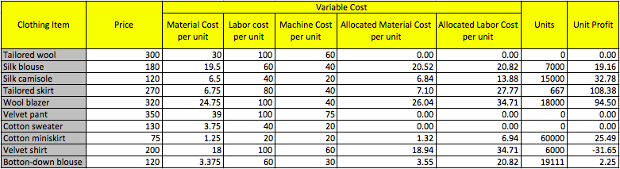 The unit profit for each item is listed in ***Table 10***

***Table 10***

* 1. **Activity-Based Costing Method (ABC method)**

Activity-based costing method allocate overhead costs to each item or each activity or each job in more reasonable way than traditional volume-based costing method. The most important or determinative activity or component for one kind of overhead cost is called cost driver. For example, designer cost is mainly determined by patterns. The company pay more money for more complex pattern. The pattern of cotton sweater is more complicated than velvet pant, so designer of overhead is allocated more to cotton sweater than velvet pant. Therefore, the unit profit calculated by this method is closer to the real unit profit, so that it is more helpful to instruct manufacturing production.

In this case, the cost drivers and total units for each indirect cost are already listed in ***Table 11.*** Cost-driver rate = total cost/total units.

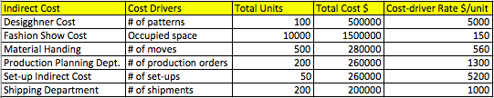

***Table 11***

In addition, the allocated activity from each indirect cost to each item is shown in ***Table 12.*** In ***Table 12***, there are three item with 0 unit, so we need to transfer the activities to other items. My adjustment method is that each activity for tailored wool slack is correspondingly allocated to tailored skirt and wool blazer by half and half, each activity for velvet pant is correspondingly allocated to velvet shirt and button-down blouse by half and half, each activity for cotton sweater is correspondingly allocated to cotton miniskirt. The updated allocation from each indirect cost to each item is listed in ***Table 12***.

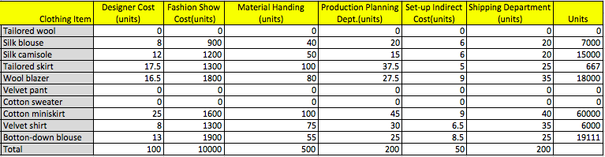

***Table 12***

Convert the allocated activity in units in ***Table 12*** to the allocated activity in $, which will be listed in ***Table 13,*** via multiplying by corresponding cost driver rate.

For each item,

Unit overhead cost = Sum of all allocated indirect cost/units

Take silk blouse for example,

Unit overhead = (40000+135000+22400+26000+31200+20000)/7000=39.23

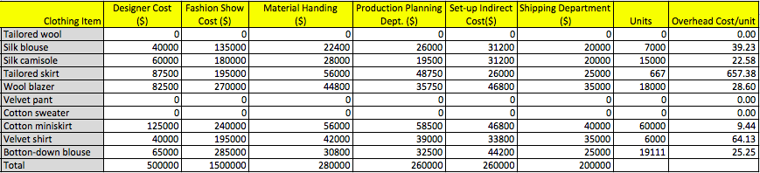

***Table 13***

Now, all the required information to calculate unit profit is available in ***Table 14***. If the units of an item are 0, the unit profit of this item must be 0,

Unit profit=price-unit material cost-unit labor cost-allocated overhead cost.

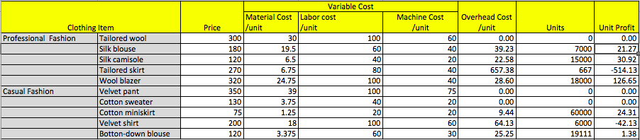

***Table 14***

* 1. **Comparison of the Two Set of Unit Profit**

I combine the dataset of units computed by LP model, unit profit gained from traditional volume-based costing method, and unit profit from activity-based costing method (ABC method) in to ***Table 15.*** The two datasets of unit profit from different costing method are close, except for tailored skirt and wool blazer; especially, tailored skirt has the highest unit profit in the traditional method but the lowest unit profit in ABC method.

Generally, the ABC method is more accurate than the traditional method as it first figures out cost drivers, then allocates overhead costs to items given the consumption of cost drivers (Hayden, 2017). In addition, sometimes, the traditional method is too simple so that it tends to ignore some important details. This case study is a great example to show the disadvantage of the traditional method. From ***Table 13***, we can see allocated cost is similar to others, but the number of tailored skirt is too tiny compared with other items, so the unit allocated overhead cost for tailored skirt become very large.

This is considered as the economy of the scale effect. When the scale becomes large, the overhead costs allocated into one product will significantly reduce, so that unit profit can be boosted.

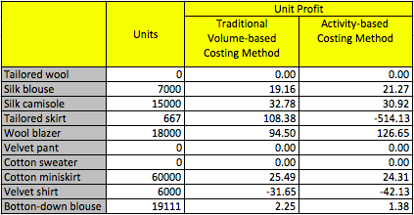

***Table 15***

1. **Conclusion**

In this case study, first of all, with the application of Linear Programming (LP), we were required to figure out the highest net profit and the optimal solution for item quantity based on the limitation of resources, demand forecast. The maximum profit generated in LP model was $3,781,833.33. When more 10,000 yards of acetate was available, we applied sensitivity analysis of the right-hand side decision to predict the increase in maximum profit, and the increase was validated by running solver with new constraints.

Production plan computed in LP model was used in both traditional volume-based costing method and activity-based costing method, aiming to develop two set of unit profit. There was a significant difference in tailored skirt, and the root cause was the tiny scale of tailored skirt. The disadvantage of traditional costing method was amplified in this situation. Also, we could apply scale effect to explain why the unit profit of tailored skirt was much lower than other items.